For this Visualisation assignment, you engage in **two**tasks and submit an rmarkdown document with a knitted result that collects the results of both tasks:

**A:** **same for everyone:** Visualize the duration of reign among Danish kings **through time**(showing the diachronic trend from ca 900 - today on the x axis) with **ggplot**. Use the dataset you/your group has created and submit both the script and the visualisation, ideally as part of an rmarkdown and html document (for details see bottom of this page). Experiment with geom_point(), geom_line() or geom_smooth() functions for the geometry.

* Udregning:  
  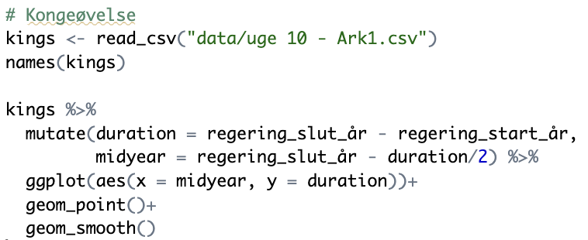
* Resultat:  
  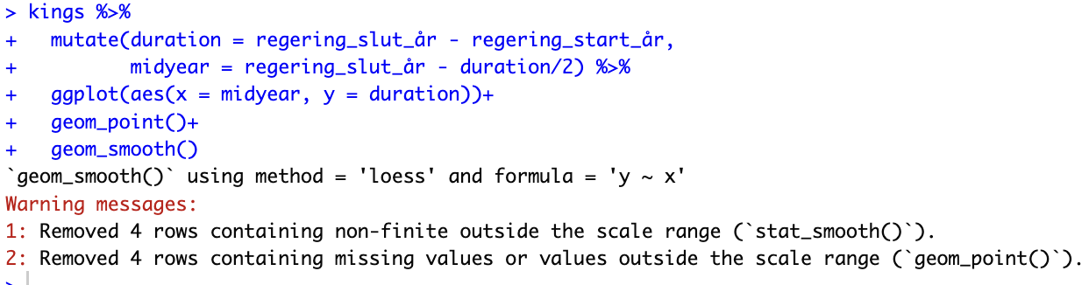
* 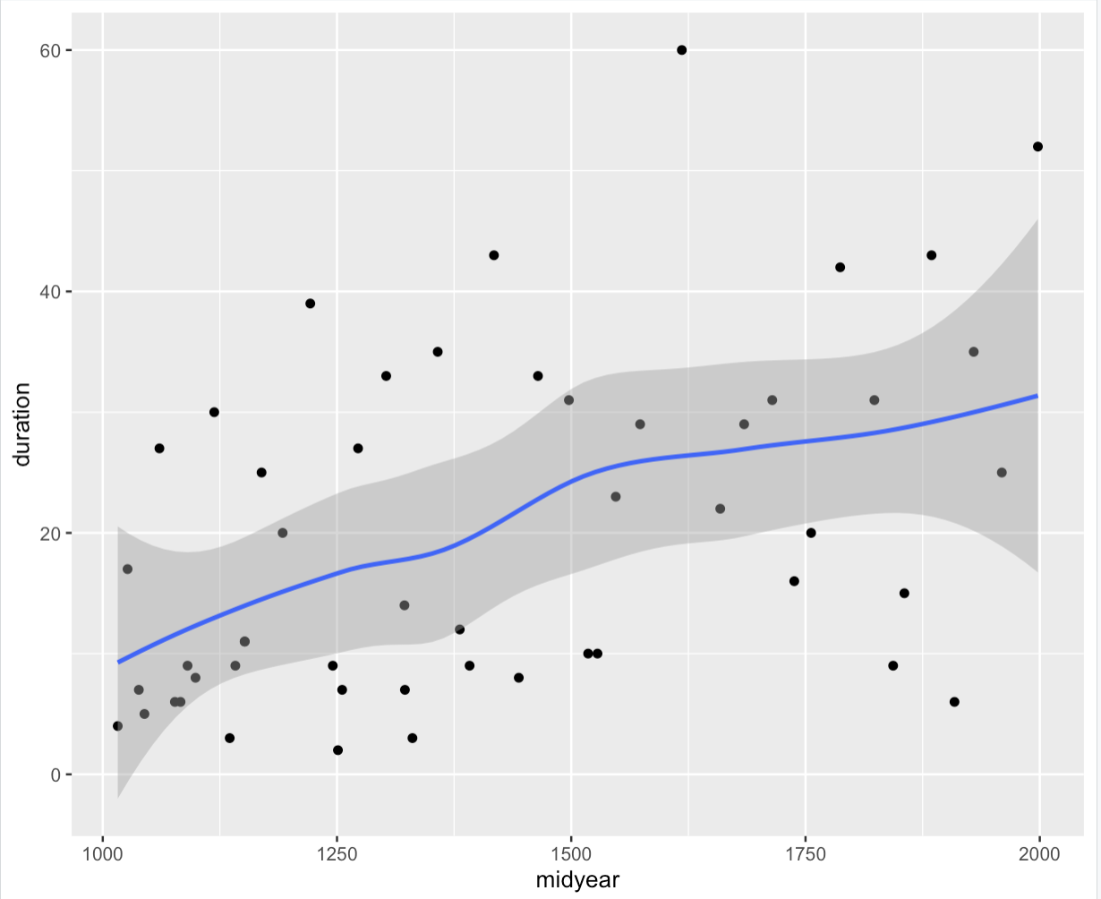

**B:** choose **one** of the two options below and follow the instructions in rmarkdowns. These have slightly different content depending on what you wish to practice. You can practice working with facets in ggplot or with producing data animations. For the latter, pay attention to the prerequisites R specified for your system:

1) Historical homicide trends across Western Europe (ggplot practice)

<https://github.com/Digital-Methods-HASS/HomicideHistory>

HTML-filen: file:///Users/astridjorgensen/Desktop/2.%20semester/Digitale%20arkiver%20og%20metoder/7.%20lektion,%20uge%2012/HomicideHistory-main/EuropeanHomicide_exercise.html

OR

2) Global development since 1957 (learn how to create animations with *gganimate* package! :)

<https://github.com/Digital-Methods-HASS/GlobalDevelopment>

**How to logistically complete this assignment**:

I am asking you to work with assignments from Github and submit answers to Github. You can do so manually following steps in this guide:

* Download the homework repository (click 'Code' button > 'download zip' button)
* Look at the .html file to see the tasks
* Edit the .Rmd file to complete the tasks (ie. create additional code chunks and comments in the text sections) and then press the Knit button to render the results as a new .html file the same way you did in Week 09 UN Votes exercise
* Upload these via 'Upload File' button to your au##### folder in Digital-Methods-HASS organization. If you wish to create a folder, click 'create new file' and then in the blank enter the name of folder with a slash behind it, eg. "week12/" and it becomes a folder instead of a file.

Submit here a *link* to **your** **au#####** repository in https://github.com/Digital-Methods-HASS ... which leads directly to the place where you have posted your solution as **both** **.Rmd** and **.html**